



Programing with Java

Arrays snacks - Student Grade

(c) Property of Semicolon Village Limited. All rights reserved by the company.





Lagbaja Schools hired you to create an application to manage student grades in their classrooms.

Write an application that allows a teacher enter scores for all his students, irrespective of number of students and numbers of subjects.

Your app should be able to do the following:

1. Ask the teacher for the number of students.
2. Ask the teacher for the number of subjects.
3. Collect the scores for every students and every subjects.
4. Constraint: Score must be between 0 and 100.
5. Display class summary after input collection.

(c) Property of Sem2icolon Village Limited. All rights reserved by the company.

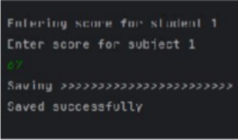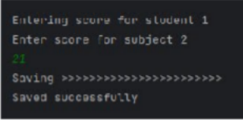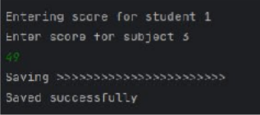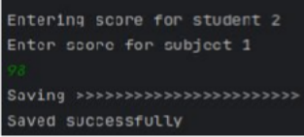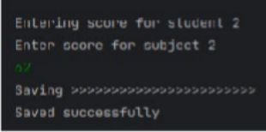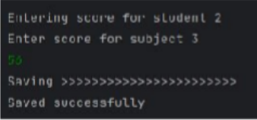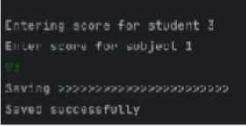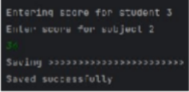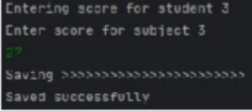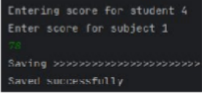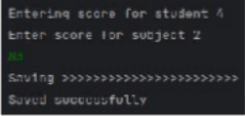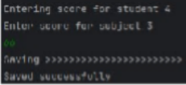



# Sample Input

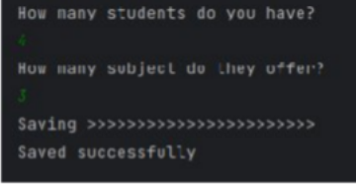

(c) Property of Sem3icolon Village Limited. All rights reserved by the company.





# Sample Output

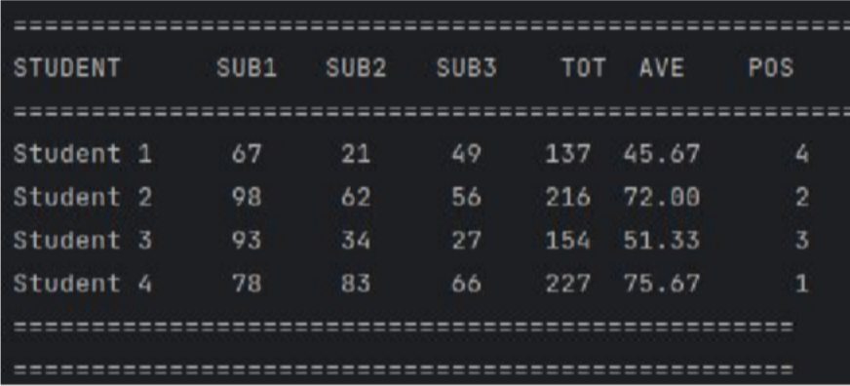

(c) Property of Sem4icolon Village Limited. All rights reserved by the company.

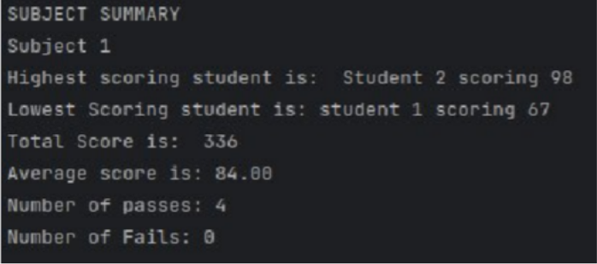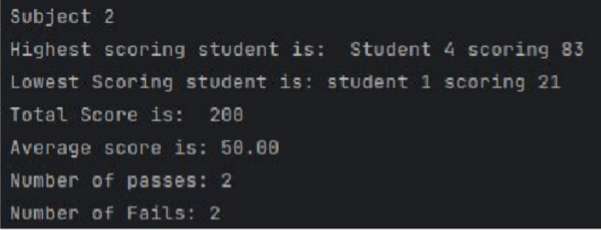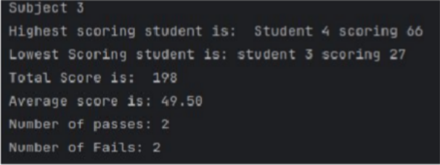



# Sample Output

(c) Property of Sem5icolon Village Limited. All rights reserved by the company.





# Sample Output

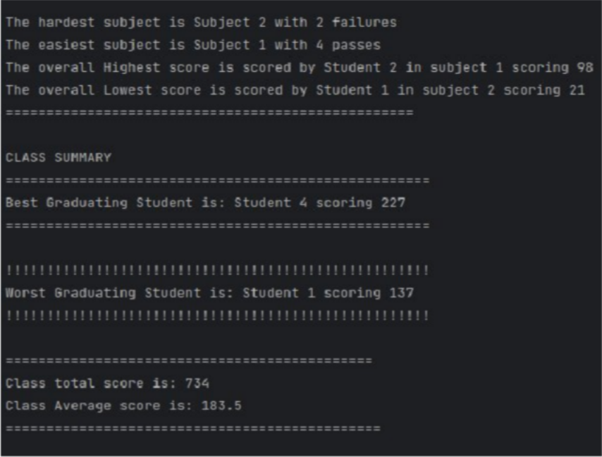

(c) Property of Sem6icolon Village Limited. All rights reserved by the company.





# Submission instruction:

Add to your existing git repository and send link.

(c) Property of Sem7icolon Village Limited. All rights reserved by the company.





Enjoy!!!



(c) Property of Sem8icolon Village Limited. All rights reserved by the company.